**Hello Team!** **Consider the below two tables**:

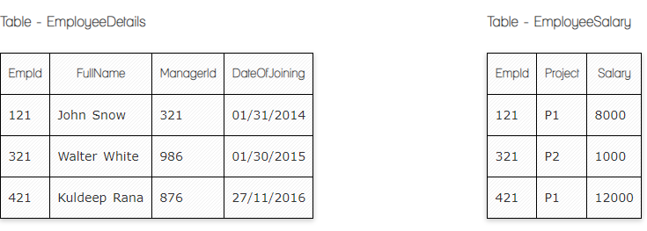

**Ques.1. Write a SQL query to fetch the count of employees working in project 'P1'.**

**Your Answer:**

**Select count * count of Project (should be count(EmpId))**

**From EmployeeSalary**

**Group by Project = ‘P1’**

**Select** **Count**(EmpId) AS Employees_P1

**From** EmployeeSalary

**Where** Project= ‘P1’;

**Ques.2. Write a SQL query to fetch employee names having salary greater than or equal to 5000 and less than or equal 10000.**

**Your Answer:**

**Select * from EmplpyeeSalary**

**where Salary > = 5000 and Salary < = 10000**

**Select** EmployeeDetails.FullName, EmployeeSalary.Salary

**From** EmployeeDetails

**Left Join** EmployeeSalary

**On** EmployeeDetails.EmpId=EmployeeSalary.EmpId

**Where** EmployeeSalary.Salary Between 5000 and 10000;

**Ques.3. Write a SQL query to fetch count of employees sorted by project's count in descending order.**

**Your Answer:**

**SELECT COUNT * AS employee_count, project  
FROM [EmployeeSalary]  
GROUP BY project  
ORDER BY COUNT * DESC** Correct

SELECT COUNT (EmpId)

FROM EmployeeSalary

Group by (Project)

Order by count(EmpId) desc

**Ques.4. Write a query to fetch employee names and salary records. Return employee details even if the salary record is not present for the employee.**

**Your Answer:**

Select * EmployeeDetails.FullName, EmployeeSalary.Salary

From EmployeeDetails

Left Join [EmployeeSalary]

ON EmployeeDetails.EmpId = EmployeeSalary.EmpId; Correct

**Ques.5. Write a SQL query to create an empty table with ‘Test’ name.**

**Your Answer:**

**CREATE TABLE Test**

**CREATE TABLE** Test(

ID int;

Name varchar(50);

Price float;

)

**Ques.6. Write a SQL query to delete an empty table with ‘Test’ name.**

**Your Answer:**

**DROP TABLE Test**

Correct

**Ques.7. Write a SQL query to fetch all the Employees details from EmployeeDetails table who joined in Year 2016.**

**Your Answer:**

**SELECT * EmployeeDetails.  
FROM EmployeeDetails  
WHERE YEAR(dateofjoin) = 2016;** Correct

**Ques.8. Write a SQL query to insert new record to the EmployeeDetails table with any data.**

**Your Answer:**

**INSERT INTO EmployeeDetails ( FullName, ManagerID, DateofJoin)**

**VALUES (237, 'John Doe', '2021-01-01', 'IT');**

**Ques.9. Write a SQL query to update EmployeeSalery table with setting Salary to 2000 for Project P2.**

**Your Answer:**

**UPDATE EmployeeSalary  
SET Salary=2000  
WHERE Project=P2;** Correct

**Ques.10. Write a SQL query to right join both tables and draw the results.**

**Your Answer:**

**SELECT *EmployeeDetails, EmployeeSalary  
FROM EmployeeDetails  
RIGHT JOIN EmployeeSalary**

**ON EmployeeDetails.FullName = EmployeeSalary.Salary**

**SELECT** EmployeeDetails.FullName, EmployeeSalary.Project, EmployeeSalary.Salary

**FROM** EmployeeDetails

**RIGHT JOIN** EmployeeSalary

**ON** EmployeeDetails.EmpId=EmployeeSalary.EmpId;

**Now take these two tables:**

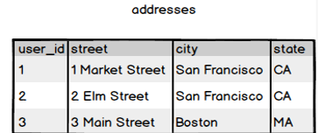

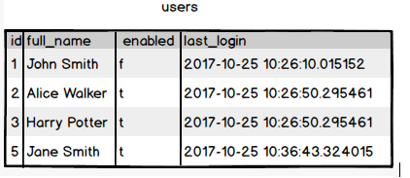

**Ques.11. Write a SQL query to fetch all users full_name from San Francisco.**

**Your Answer:**

**SELECT full_name,users  
FROM users**

**ON users.id=addresses.user_id  
WHERE city = 'San Francisco';**

**SELECT** users.full_name

**FROM** users

**INNER JOIN** addresses

**ON** users.id=addresses.user_id

**WHERE** city=’San Francisco’;

Correct

**Ques.12. Write a SQL query to fetch all users full_name, last_login who are enabled**

**Your Answer:**

**SELECT full_name, last_login  
FROM users  
WHERE enableId = ‘t’;** Correct

**Ques.13. Write a SQL query to fetch all users full_name who are not from Main street**

**Your Answer:**

**SELECT users.full_name  
From users  
INNER Join addresses  
On users.id=addresses.user_id  
WHERE NOT addresses. Street=’Main’**

Correct

**Ques.14. Write a SQL query to fetch all users full_name who are from Main street or San Francisco**

**Your Answer:**

**SELECT full_name  
FROM users  
WHERE address LIKE 'Main Street' OR city = 'San Francisco';**

**SELECT** users.full_name

**FROM** users

**INNER JOIN** addresses

**ON** users.id=addresses.user_id

**WHERE** street=’Main street’ or city=’San Srancisco’;

**Ques.15. Write a SQL query to fetch user full_name who is equal to user_id from Boston (find user_id value in sub_query)**

**Your Answer:**

**Select FullName**

Select * from Users

Where ID in (Select User_id From Addresses

Where city = ‘Boston’)